**Q1**

**Excel:**

Excel is a spreadsheet program from Microsoft and a component of its Office product group for business applications. Microsoft Excel enables users to format, organize and calculate data in a spreadsheet.

By organizing data using software like Excel, data analysts and other users can make information easier to view as data is added or changed. Excel contains a large number of boxes called cells that are ordered in rows and columns. Data is placed in these cells.

**Uses of Excel:**

* collection and verification of business data;
* business analysis;
* data entry and storage;
* data analysis;
* performance reporting;
* strategic analysis;
* accounting and budgeting;
* administrative and managerial management;
* account management;
* [project management](https://www.techtarget.com/searchcio/definition/project-management); and
* office administration.

**Q2**

**Excel versions:**

* Excel 365
* [Excel 2021](https://thesmartmethod.com/excel-versions-explained/#2021)
* [Excel 2019](https://thesmartmethod.com/excel-versions-explained/#2019)
* [Excel 2016 and 365](https://thesmartmethod.com/excel-versions-explained/#2016)
* [Excel 2013 (Windows)](https://thesmartmethod.com/excel-versions-explained/#2013)
* [Excel 2011 (Mac)](https://thesmartmethod.com/excel-versions-explained/#2011)
* [Excel 2010 (Windows)](https://thesmartmethod.com/excel-versions-explained/#2010)
* [Excel 2008 (Mac)](https://thesmartmethod.com/excel-versions-explained/#2008)
* [Excel 2007 (Windows)](https://thesmartmethod.com/excel-versions-explained/#2007)
* [Excel 2004 (Mac)](https://thesmartmethod.com/excel-versions-explained/#2004)
* [Excel 2003 (Windows)](https://thesmartmethod.com/excel-versions-explained/#2003)
* [Older Windows versions (2002, 2000, 97, 95, 4.0, 3.0, 2.0)](https://thesmartmethod.com/excel-versions-explained/#olderwindows)
* [Older Mac versions (2001, 2000, 98, 5, 4, 3, 2, 1)](https://thesmartmethod.com/excel-versions-explained/#oldermac)
* [OS/2 Versions (2.2, 2.3, 3)](https://thesmartmethod.com/excel-versions-explained/#os2)

**Comparison between Excel and google sheets:**

|  |  |  |
| --- | --- | --- |
| * Category | * Microsoft Excel | * Google Sheets |
| * Developed by | * Microsoft Corporation developed MS Excel. | * Google LLC developed Google sheets. |
| * Launched as a pack of | * They launched MS Excel as a pack of MS Office. | * They launched google sheets as a pack of G Suite. |
| * Launching Year | * 1987 | * 2006 |
| * Languages supported | * Excel is available in 91 languages. | * Google Sheets are available in 83 languages. |
| * Performance | * Great for a high volume of data. | * Great for low volumes of data (less than 400,000) cells. |
| * Collaboration | * Compared to Google sheets, Excel is a not favorable application for collaboration. | * Google sheets are the preferred application for collaboration. |
| * Tools for statistical analysis and visualization | * Excel is a superior product in the case of statistical analysis and visualization. | * If you want to perform any analysis, you have to do it manually. |
| * Online offline usability | * We can use Excel in offline mode. | * We can use Google Sheets in both online as well as offline mode. |
| * Chatting facilities | * Excel does not have this facility. | * In Google Sheets, a chatting facility is available on the sidebars. |
| * Macros | * Yes | * No |
| Scripting | VBA | Apps Script |

**Q3**

**Steps to create bar chart:**

1. Enter data in a spreadsheet.
2. Select the data.
3. Excel 2016: Click Insert > Insert Column or Bar Chart icon, and select a column chart option of your choice.
4. Data

|  |  |
| --- | --- |
| 1. RowNumber | 1. Gender |
| 1. 1 | 1. Female |
| 1. 2 | 1. Female |
| 1. 3 | 1. Female |
| 1. 4 | 1. Female |
| 1. 5 | 1. Female |
| 1. 6 | 1. Male |
| 1. 7 | 1. Male |
| 1. 8 | 1. Female |
| 1. 9 | 1. Male |
| 1. 10 | 1. Male |
| 1. 11 | 1. Male |
| 1. 12 | 1. Male |
| 1. 13 | 1. Female |
| 1. 14 | 1. Female |
| 1. 15 | 1. Female |
| 1. 16 | 1. Male |
| 1. 17 | 1. Male |
| 1. 18 | 1. Female |
| 1. 19 | 1. Male |
| 1. 20 | 1. Female |

Bar chart

**Q5: Connect Excel and load data**

1. To connect Excel to a database in SQL Database, open Excel and then create a new workbook or open an existing Excel workbook.
2. In the menu bar at the top of the page, select the Data tab, select Get Data, select From Azure, and then select From Azure SQL Database.

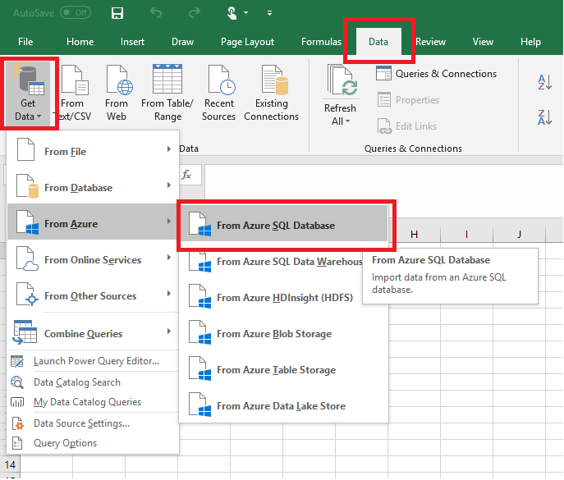

1. In the SQL Server database dialog box, type the Server name you want to connect to in the form <servername>.database.windows.net. For example, msftestserver.database.windows.net. Optionally, enter in the name of your database. Select OK to open the credentials window.

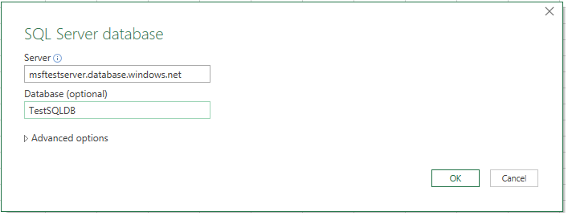

1. In the SQL Server database dialog box, select Database on the left side, and then enter in your User Name and Password for the server you want to connect to. Select Connect to open the Navigator.

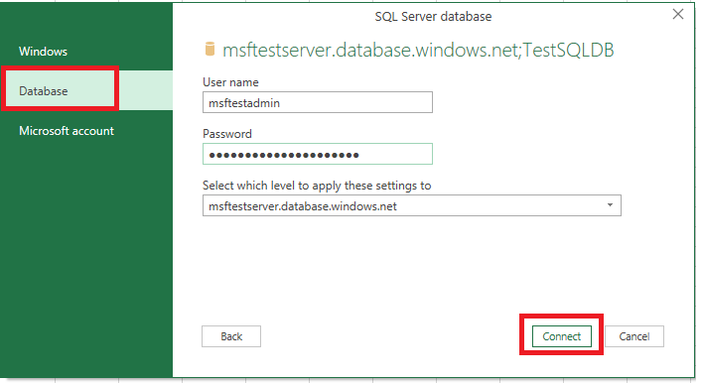

1. In the Navigator, select the database you want to work with from the list, select the tables or views you want to work with (we chose vGetAllCategories), and then select Load to move the data from your database to your Excel spreadsheet.

